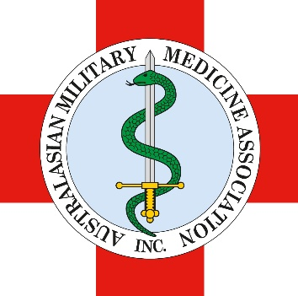
AMMA Educational Workshop Series
Tropical Medicine Workshop Programme
Associate Prof Dr Richard Bradbury

Friday 21 March 2025, Brisbane, QLD
0830 | Arrival coffee and tea
0850 | Introduction | Associate Prof Dr Richard Bradbury
0900 | Update on malaria – clinical and diagnostic | Associate Prof Dr  Richard Bradbury
1000 | Update on malaria - prophylaxis and treatment | Guest Speaker from ADF MIDI
1030 | Morning tea
1100 | Update on arboviruses | Associate Prof Dr  Richard Bradbury
1130 | Leishmaniasis & the filariases | Associate Prof Dr  Richard Bradbury
1200 | Rickettsial diseases (incl. scrub typhus), typhoid, and cholera | Associate Prof Dr  Richard Bradbury
1300 | Lunch
1345 | Skin diseases and tropical STIs | Associate Prof Dr  Richard Bradbury
1445 | Intestinal parasites | Associate Prof Dr  Richard Bradbury
1545 | Workshop concludes

